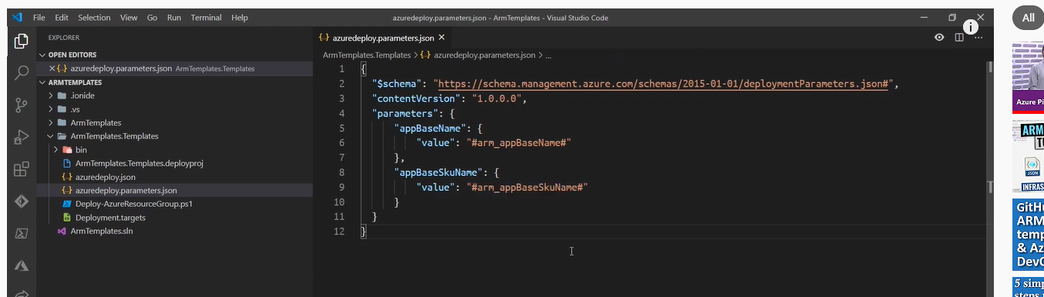

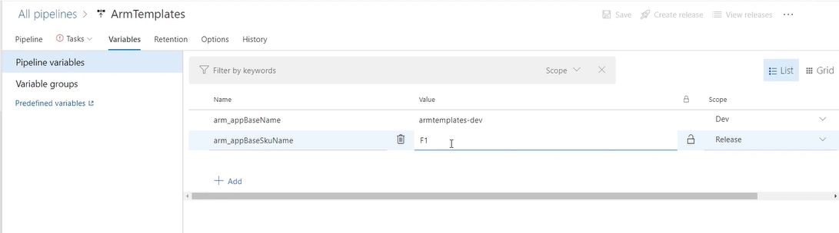

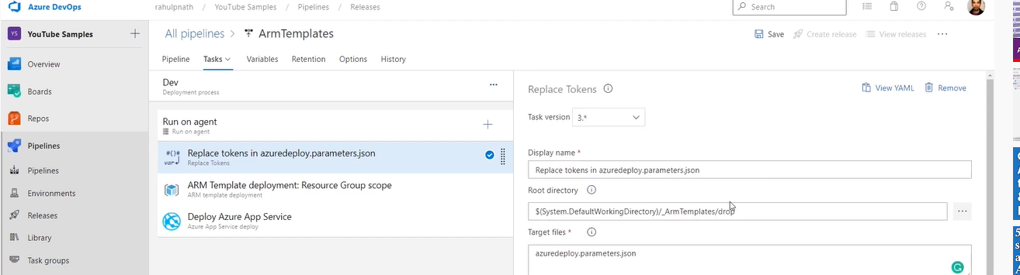

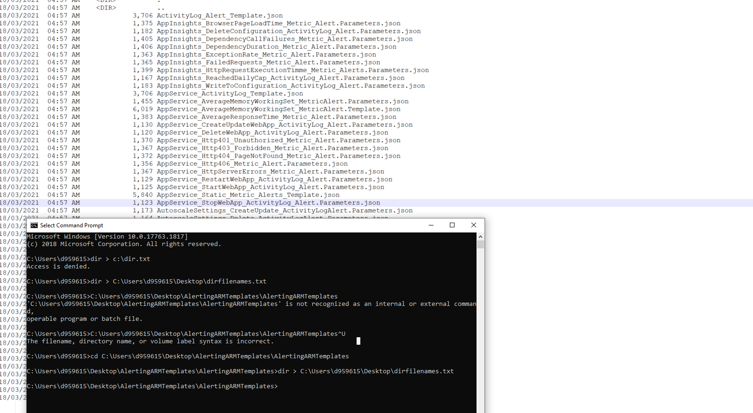

https://superuser.com/questions/395836/how-to-copy-a-list-of-file-names-to-text-file/395838